Our Fleet

At MK Partnair, we carefully select the airplane best adapted to your needs.

Whether flying from Paris to Nice or from Doha to New York, all destinations are within range thanks to our large selection of private jets.

Use the menu below to learn about the airplanes which best correspond to your needs :

Filter

All aircraft, Passengers, Luggage, Distance, Speed

Light Jet

Cessna Citation Jet 2

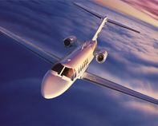 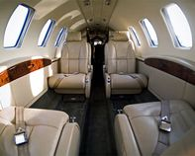 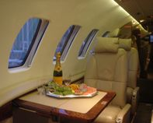

|  |  |
| --- | --- |
| **Passengers** | **6** |
| **Number of Engines** | **2** |
| **Toilet** | **Yes** |
| **Maximum Speed (km/h)** | **760** |
| **Maximum Range (km)** | **2800** |
| **Recreation Center** | **No** |
| **Stewardess** | **No** |
| **Crew** | **2** |

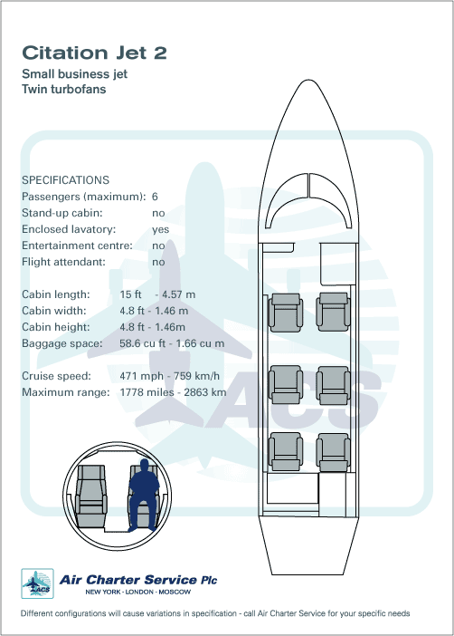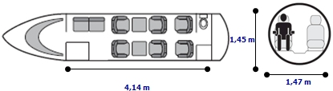

All aircraft are chartered with crew and meet the strictest safety standards.

For further advice on chartering aircraft and to learn which aircraft is most suitable for your plans, contact us at 33.1.56.56.56.56